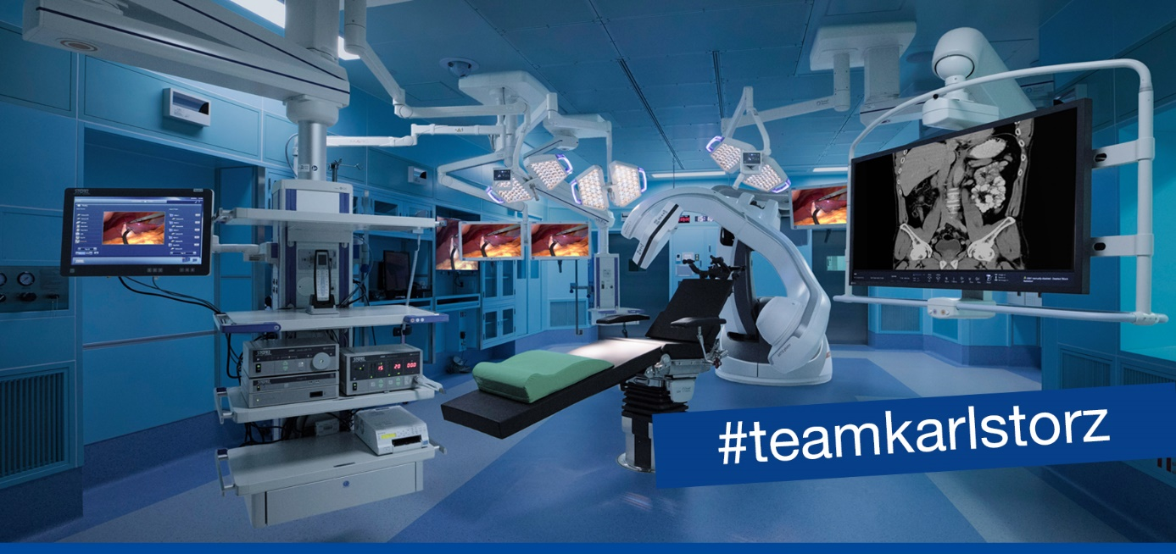

KARL STORZ SE & Co. KG based in Tuttlingen, Germany, is a family-owned, global company with more than 8.500 employees committed to benefiting humanity by advancing medical technology through innovation and education. For more than 75 years, KARL STORZ has been dedicated to earning its international reputation as a leader that designs, engineers, manufactures, and markets all its products with an emphasis on visionary design, precision craftsmanship, and clinical effectiveness. Across all continents, KARL STORZ is represented by more than 50 KARL STORZ subsidiaries in over 40 countries.
To strengthen our team, KARL STORZ CROATIA d.o.o. have a vacancy for a:

Trainee Sales Representative (m/f/d)

- Full time
- Reporting line: Sales Manager

Tasks and Responsibilities after a training period:
- Responsible for the development and maintenance of sales in a specific territory/ for specific product lines and accounts
- Ensuring that defined sales and profit targets are consistently met and operating within established policy guidelines
- Develops new accounts by researching and identifying potential leads, soliciting new business, building connections, providing technical information and advices
- Planning and organizing daily/weekly sales visits and documentation
- Giving demonstrations, trainings and presentations to help clients discover and understand products/services
- Preparing proposals and quotations
- Attending and participating in organization of trade exhibitions, conferences and workshops/hands-on trainings
- Coordinate with other team members and departments to optimize the sales effort
- Working with team manager to plan how to approach clients

Requirements:
- A bachelor’s degree Electrical Engineering and Computing, Mechanical Engineering or a related field
- Proficiency in English and good computer skills
- A valid driver’s license and the willingness to travel extensively
- Technical interest and a comprehensive understanding of how the company products work

- After a period of training: Thorough understanding of equipment, products, industry, and/or services provided to clients
- The ability to identify and follow up on leads
- Professional interpersonal and customer service skills
- Professional verbal and written communication skills
- Knowledge of sales promotion techniques and/or talent for selling products
- Strong analytical and problem-solving skills
- Ability to absorb complex technical information and communicate simply to others
- Prioritizing, time management and organizational skills
- Teamworking skills
- Strong work ethic
- Willingness to learn, especially technical and medical information

Our offer:
- We offer a competitive salary and an additional performance-related bonus payment
- A company car
- An international work environment in a successful, global organization and a meaningful occupation in the medical device industry
- Flexible working hours
- Professional product training in the beginning and afterwards regular trainings and courses

Your application:
KARL STORZ is an equal opportunity employer and committed to diversity and inclusion. We welcome applications from all suitably qualified candidates. To apply for this position please assemble your application documents in English or Croatian, consisting of your motivation letter, CV and reference letters and send them to the following email:
suzana.corak@karlstorz.com

For more information about KARL STORZ please visit our website: http://www.karlstorz.com

